Telecom Data Engineering & Analytics Pipeline Using Azure Databricks

Introduction
The fast-paced growth of telecom data provides us with the opportunity to draw meaningful insights to improve engagement of customers, operational efficiency and generation of revenue. The main aim of this project is to do the designing and implementation of an end-to-end data pipeline in azure data bricks to do the processing of raw telecom data and change it into an actionable insight of business.
The solution provided in this project combines processing of data, analytics and machine learning to perform the identification of high value customers, analysis of regional and parent channel performance, and enablement of data sharing through APIs and dashboards.

Solution Overview
In this solution, medallion architecture has been used, where multiple layers have been used for sake of better quality and usability.
Raw Data → Bronze → Silver → Gold → ML Model → API → Dashboard
Components
The components of the solutions are as follows:
- Bronze Layer: Ingestion of Raw Data
- Silver Layer: Cleaning of Data and transformation done
- Gold Layer: Business Ready Aggregations
- ML Model: The prediction of high value customers
- API: The sharing of processed data
- Dashboard: To display insights in form of meaningful charts
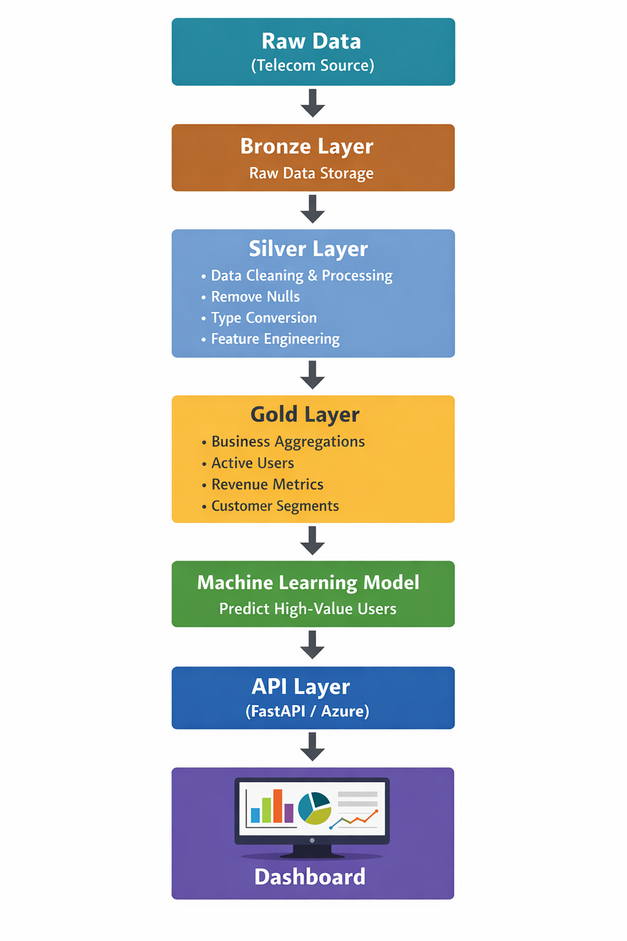
Figure 1 Solution Overview

Data Schema Description
The dataset used in this project contains customer data with attributes which are related to usage, recharge behavior and demographics.
Column Name | Data Type | Description
msisdn | string | Unique customer identifier
region | string | Customer region
sales_channel | string | Sales source
parent_channel | string | Parent distribution channel
sale_date | date | Date of sale
first_active_date | date | Activation date
total_recharge_90d | double | Total recharge in last 90 days
activity_status | string | Active/Inactive
quality_sale_flag | int | Quality sale indicator
Table 1 Schema Description

Pipeline Description
In the pipeline we have three layers based on medallion architecture, its description is as follows:
Bronze Layer
- Storing raw telecom data
- No transformations have been applied in this layer
Silver Layer
Data cleaning is done in this layer, and the following things are done in this layer:
- Removing null and duplicate values
- Standardization of data types
In the feature engineering following features are selected:
- Customer lifetime
- Activity status
- Total recharge
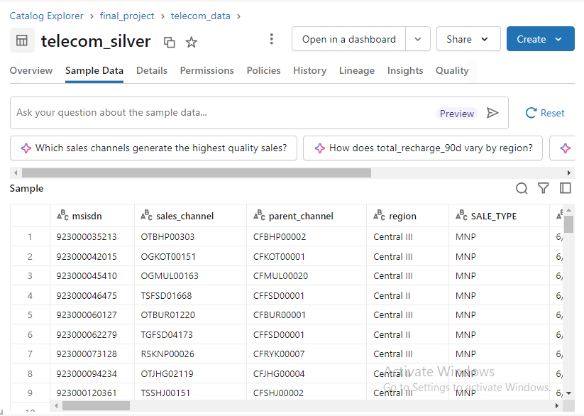
Figure 2 Screenshot from Silver Layer Processed Table
Gold Layer
In the gold layer, aggregation of following business insights is done:
- Active users by region
- Channel performance
- Customer segmentation
- Quality sales metrics
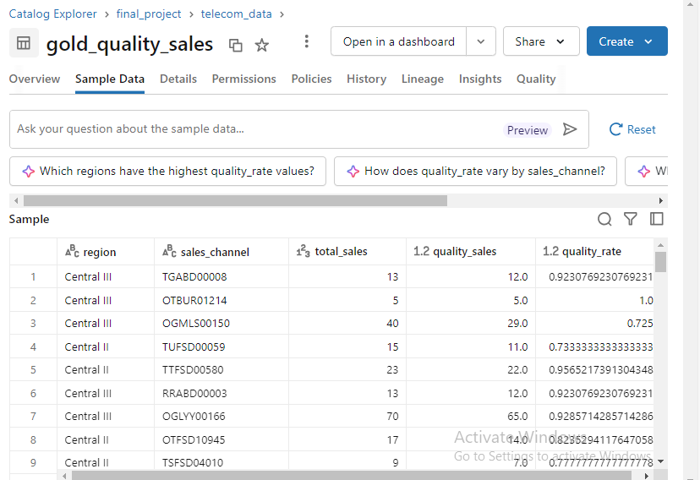
Figure 3 Gold Layer Processed Data on Quality of Sales
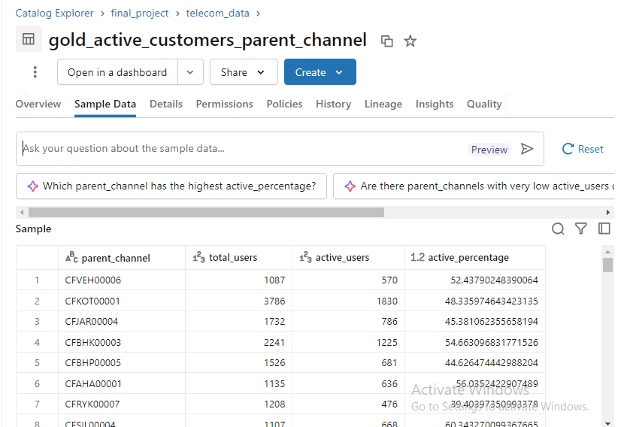
Figure 4 Gold Layer Active Customers Data

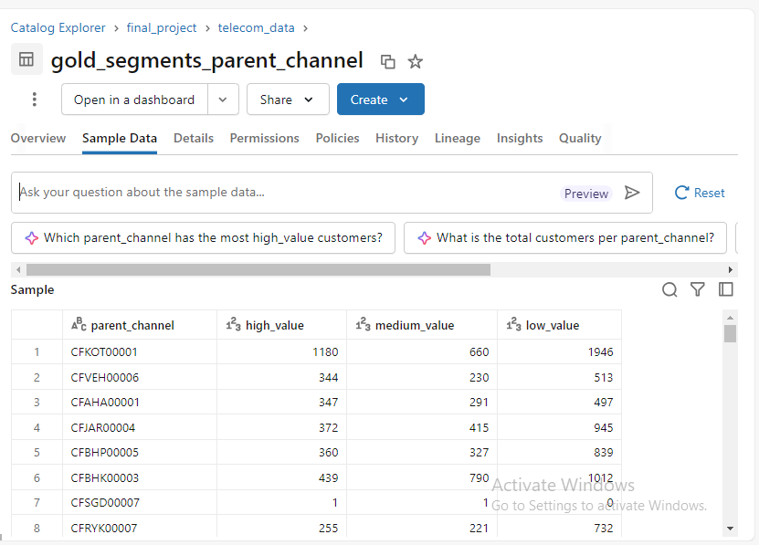
Figure 5 Gold Segment Data Process for High, Medium and low Value Customers

Machine Learning Model
To train a machine learning model, we choose a logistic regression model which is implemented with the help of ML flow to predict whether a customer will likely a high value or low value. The features used are as follows:
- Region
- Sales channel
- Parent channel
- Recharge values (7-day, 30-day)
- Customer lifetime
Output
The output we achieved is in the form of 1 and 0. If it’s 1 then customer is of high value, else in case of zero it’s not. I added probability as well for the sake of confidence score of predictions.

Evaluation
For the evaluation we used accuracy and AUC metrics to judge its performance. Its AUC score is quite good.
Predictions Table
The predictions done by our model is also stored in form of table. It can be seen as follows:
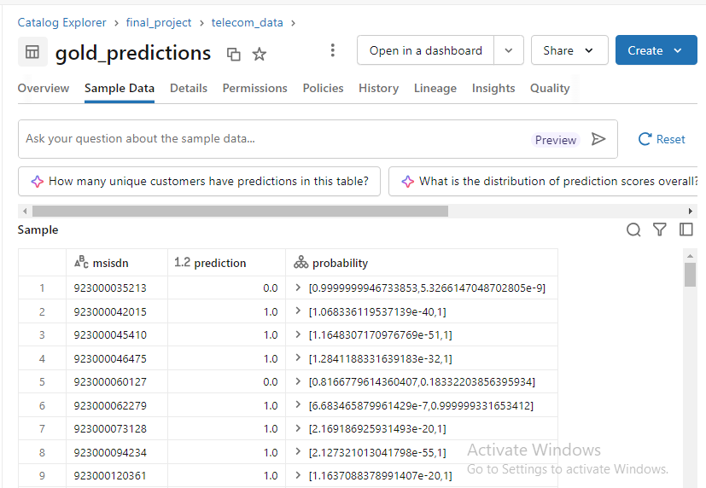
Figure 6 Predictions Done by Model

Dashboard Visualization
A dashboard is also created based on the data produced from gold layer and from silver layer. For this we used Azure databricks built in dashboard feature, where data is just simply loaded from schema.
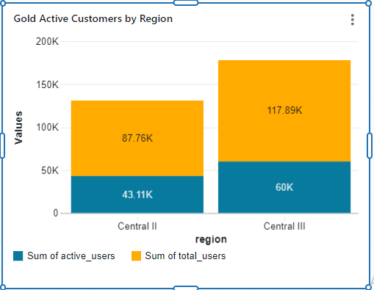
Figure 7Gold Active Customer by Region
In the figure above, we visualized the total users for both regions, Central II and Central III. In central II we have users 87.76k and out of them 43.11k are active and in case of central III, users are 117.89k and out of them 60k are active.

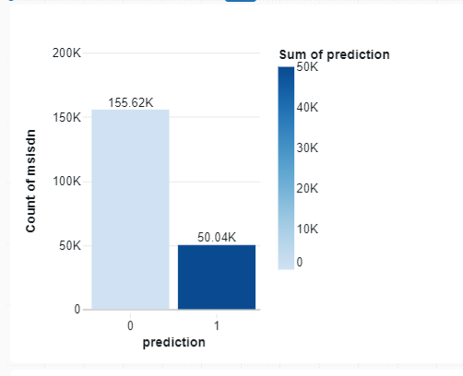
Figure 8 Prediction for High Value Customers
In this visualization 50.04k customers will be high value customers.
The rest of visualization can be shown in the GitHub dashboard file.

Data Sharing & API
The APIs are also created for the following features:
- Retrieve high-value customers
- Provide prediction results
The model to provide predictions is hosted on azure serving and for high value customers we are using fast APIs.

Data Product Features
Data Contract

- In this we Defined scheme for input and output of data
- Ensures consistency across pipeline
Data Validation
- Checking Null Values
- Checking of Duplicated
- Constraints on Values
Logging
- Tracks pipeline execution
- Helps in debugging
Automated Testing
- Validation of Schema
- Quality Checks of Data

Innovation & Scope
The project we created demonstrates end-of-the-end data pipeline creation, integration of machine learning models, real-world telecom analytics, API-based data sharing and scalable and modular architecture.

Conclusion
This project has successfully transformed raw telecom data into useful informative insights using modern engineering practices of data. It demonstrates a scalable data solution as it uses ml, dashboard which enhances its decision-making capabilities about business.

